


Summer School on Data Analytics and Artificial Intelligence
with Grand Valley State University, USA
28 June – 25 July 2026

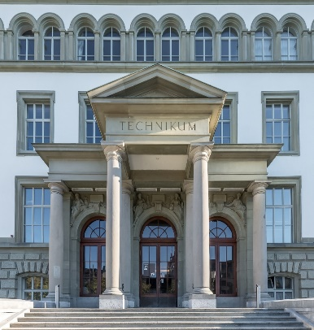

2 weeks on SoE campus, Switzerland 2 weeks on GVSU campus, USA

Fact Sheet Summer School 2026

Link Website Summer School

Dates and Location | 28 June – 25 July 2026  First two weeks (28 June-11 July) will take place at the SoE campus in Winterthur, the following two weeks (12 July – 25 July) at the GVSU campus in Allendale, Michigan, USA.  The SoE programme consists of scientific inputs in the fields of Data Engineering and Machine Learning. The GVSU programme consists of inputs and lectures in the fields of Data Visualization and Deep Learning. You will work on a project during the entire 4 weeks, in mixed groups with peers from the USA and different study programmes.  The weekends in both countries are filled with exciting excursions and trips.  If you plan a private trip back-to-back to the Summer School in the USA, this is possible.
Student Group | Students from both universities will participate in the entire programme (4 weeks), including weekend excursions.
Study Programme and Term Level | At SoE, students from the following study programmes are eligible to participate:  Computer Science (IT), Data Science (DS), Electrical Engineering (ET), Engineering and Management (WI) and Systems Engineering (ST).  Eligible term levels:  Participating students must have completed the 2nd year/4th semester (full-time studies) or completed 3rd year/6th semester (part-time studies).  For DS and IT part-time studies, it is also possible to participate after the 2nd year/ 4th semester after consultation with their respective programme directors.
Prerequisites | To participate you need to master the basics in Linear Algebra and Analysis and have an advanced level in Python programming.  English Level B2 is compulsory.
Content of the Programme | Week 1 (ZHAW): Data Engineering  Week 2 (ZHAW): Machine Learning  Week 3 (GVSU): Deep Learning  Week 4 (GVSU): Data Visualization
ECTS-Credits | 6 ECTS will be awarded for the summer school.  WI 6 ECTS in the module group WI6  IT/ DS/ ST/ ET WPFM context with 2 ECTS and WPFM interdisciplinary with 4 ECTS  Students can use the earned credits to count for the International Profile requirement. This is eligible for all study programmes eligible for the summer school.  The credits are credited for the academic year following the Summer School, HS 26/27.
Costs  (depending on the number of participants) | CHF 1’700 - 1’900.-  CHF 1’000 - 1’300.-  CHF 2’700 - 3’200.- | Participation in Summer School and stay at GVSU  (lectures, excursions, accommodation and boarding in the US)  Individual flight costs  (Participants book and pay for their own flights)  Total (estimated)
Accommodation USA | Grand Valley State University (Campus Allendale)  - https://www.gvsu.edu/housing/murray-living-center-apartments-105.htm  - www.gvsu.edu/housing/
Information session | - Online information session on Thursday, 26th November 2025, 17:45, on MS Teams
Registration | - Registration for the Summer School until February 13st 2026,  by e-mail to international.engineering@zhaw.ch  - You will find the registration form on the intranet  https://intra.zhaw.ch/departemente/school-of-engineering/international/summer-schools

